|  |  |
| --- | --- |
|  | [Document title] |
|  |  |
|  | Dmitrii Ponomarev  Data Landscape  12/1/23 |

Table of Contents

Chapter 1 1

Chapter 2 Introduction 1

Chapter 3 Unit testing 1

Chapter 4 Data analysis 1

Chapter 5 Conclusion 1

Chapter 6 Table of figures 1

Chapter 7 References 1

# Introduction

## Description

While choosing the dataset to analyse for the coursework, I have stumbled across a dataset including average IQ of a country alongside with other parameters, such as literacy rate, HDI (Human Development Index) and how many times the country won the Nobel prize. Instantly I got invested in factors affecting countries that have the highest and the lowest count for Nobel prises.

## Hypothesis

[TK]

## Data Overview

After dropping erroneous and null data, I was left with 179 countries which have information about their continent/region all shown in figure 1.

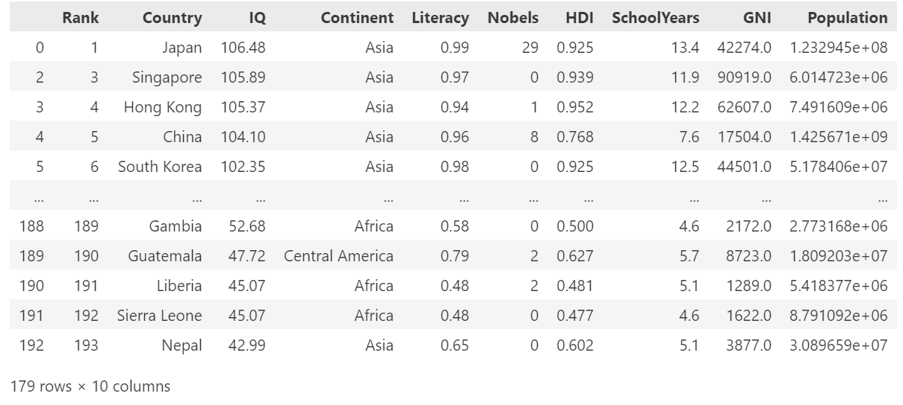

Table 1 - Dataset example

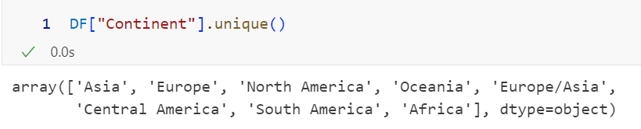

Figure 1 - Regions in the data set

### Data limitations

Unfortunately, the dataset isn’t updated fully and contains columns from 2021 (HDI and GNI), which come from a different dataset created by the same person in 2021. I have to assume that both of these parameters didn’t change much since that time and my results would be valid. [TK]

# Unit testing

# Data analysis

# Conclusion

# Table of figures

# References